
Vic Crash- Blackspot analysis


Ramandeep Kaur

Contents
Executive Summary 3
Business Understandings and Business Problems to address 4
Data understanding, Data cleaning and preparation 4
The Machine Learning model undertaken 8
Model and the performance metrics 9
Pros and cons of the logistic regression model 11
Business Solution and recommendations 12
References 13

Executive Summary
This business report showcases VicCrashAnalytics' collaboration through a consulting contract with the Victorian government's Department of Transport (DOT). The primary objective of this partnership is to evaluate the contributing factors to blackspots, also known as accident-prone areas, based on various characteristics associated with demographics of the surroundings. The purpose of the project is to identify these influential factors, extract valuable insights from the data, and utilize this knowledge to formulate effective campaigns, intervention strategies and policy reforms while predicting the likelihood of blackspots.

The analytical process begins with a meticulous examination and comprehension of the provided data, followed by a comprehensive exploratory data analysis involving univariate, bivariate, and multivariate visualizations. Leveraging the insights gained, a Logistic Regression Model is employed to classify instances as either blackspots or non-blackspots.

Crucial insights are distilled from the data, further enhancing the depth and value of the analysis. Data from the ‘Blackspot.csv’ is used to perform descriptive and predictive analysis. This multifaceted approach not only empowers a thorough evaluation but also amplifies the overall significance of the data assessment.
This extensive examination empowers VicCrashAnalytics to present suggestions and remedies concerning the challenge of blackspots within Australia.

Business Understanding and the Business problems to address

Needs: The need is to address the issues regarding the blackspots or accident-prone areas in Australia by having insights into the data and determining the factors contributing to Blackspots.

Value: The project’s value revolves around creating a safer road environment, potentially saving lives and reducing accidents by predicting the blackspots in Australia. Proper utilisation of government resources ensured for maximum impact.

Stakeholders: Stakeholders, group or individual with a relationship to the change, the
need or the solution of blackspots would be the Client- Department of Transport (DOT), VicCrashAnalytics Team, government Representative (other agencies responsible for road safety), General Public, Data provider, Legislators and policy makers.

Solution: Advanced predictive modelling such as logistic regression has been utilised for predicting the blackspots. Education campaigns, infrastructure enhancement, traffic management strategies, effective policies will be implemented to minimise the risks and enhance the well-being and safety of the Australian communities.

Change: Proper training regarding safety measures, enhancements of road designs and campaigns for creating awareness among people about safety are some of the necessary changes that can be implemented.

Context: Policy reforms, campaigns and infrastructure enhancements shall be made in accordance to the laws of Department of Transport for them to be effective in long run. Campaigns shall be designed for the accurate target audience.

Data Understanding, Data cleansing and preparation, exploratory data analysis and visualisation and insights gained

Data Understanding: In accordance with the dataset furnished to VicCrashAnalytics by the DOT, likelihood of blackspots was predicted on the basis of 30+ characteristics regarding the demographics of the surrounding road segments. 5326 Observations and 36 Variables, attributes, features, predictors containing float, integer and object were provided. “Blackspot” being the target value or label (y) for constructing the machine learning model.

Among these variables categorical variables EZI_ROAD_NAME', 'ROAD_NAME', 'ROAD_TYPE', 'Intersection', and 'Blackspot' have been provided. In addition, numerical variables encapsulate a range of attributes such as age percentages, family composition and count of cars within each household.

While addressing the missing values in the dataset, strategies were employed during the analytical process to ensure comprehensive data integrity.

Given the diverse features, potential insights were gained regarding the dynamics of road safety by performing thorough analysis to evaluate the impact of such features on the occurrence of blackspots.

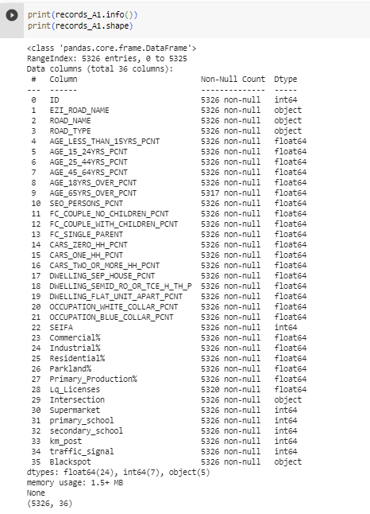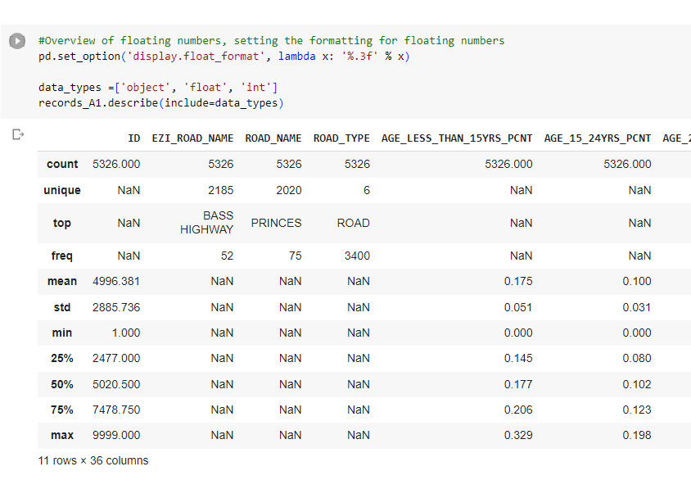
Understanding the Data

Furthermore, a summary of statistical measures such as mean, standard deviation, min, max, etc., have been evaluated using the describe () function.

Data cleansing and preparation: Data type conversions were made for the categorical variables ‘Blackspot’ and ‘Intersection’ as machine learning models can’t perform on categorical variables (strings). Using the Laber encoder function data types were converted into numerical labels. Each unique categorical value was assigned a unique integer label (Great Learning Team, May 2023). Separate New columns were made for numerical versions of the data. Label encoding has been convenient for analysis as it is automated and maintains original data for interpretation.
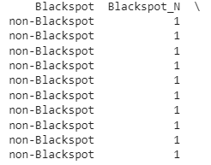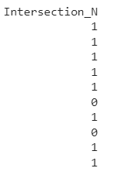

During the pre- processing of data, empty strings were replaced with the missing values to ensure consistency and precise analysis.
'AGE_65YRS_OVER_PCNT' and 'Lq_Licenses' had 9 and 6 missing values respectively. Since the data for both the variables were skewed as visualised by histogram and boxplots, Median was used to replace the missing values as it is less sensitive to outliers than the mean. (Ajitesh Kumar, March 26, 2023, Data Analytics, Vitaflux).

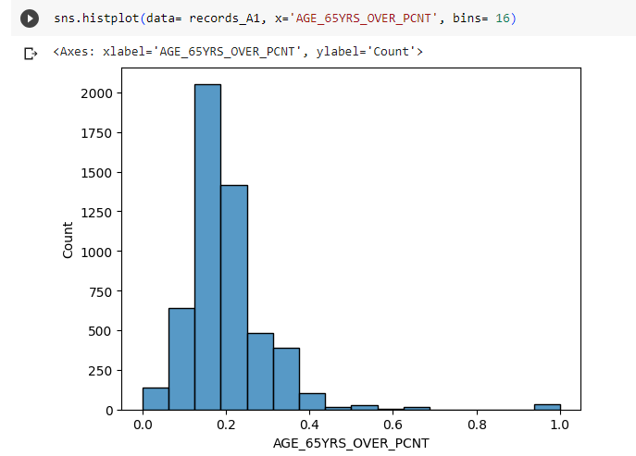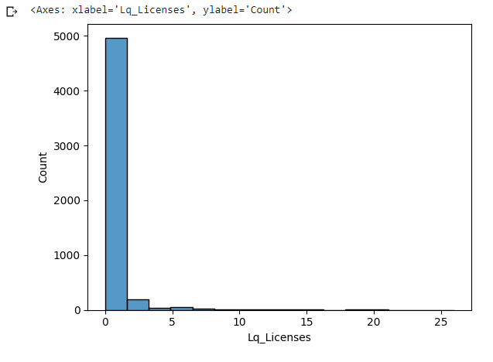

Visualisation: It is vital to do an in-depth analysis of the data to understand the patterns and important variables.

Univariate analysis:
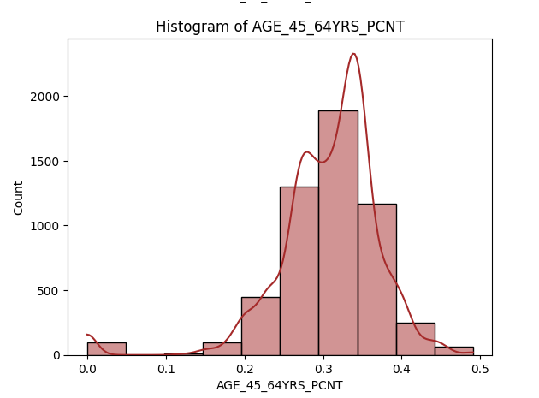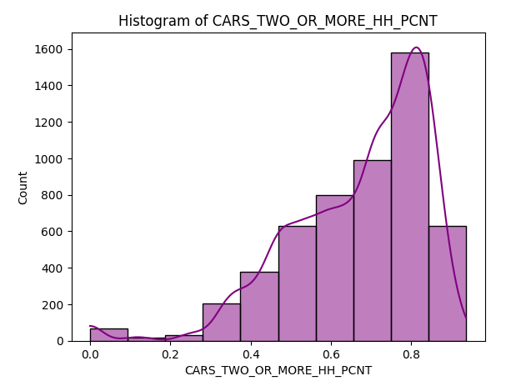

The distribution of 45-64 years of age is concentrated between 0.3 to 0.4 midpoints. The distribution of households with 2+ cars is concentrated around 0.8 having a mode greater than median. The distribution for both variables is left skewed as per the histogram and KDE graph plotted. Both variables are important features employed in the machine learning model to predict Blackspots.

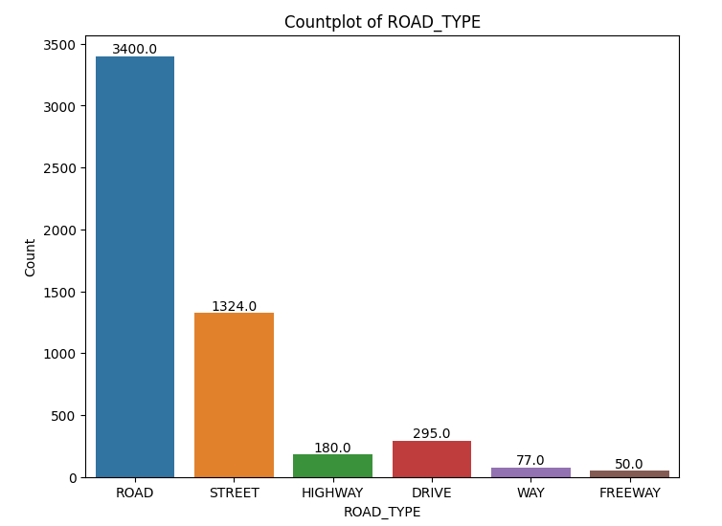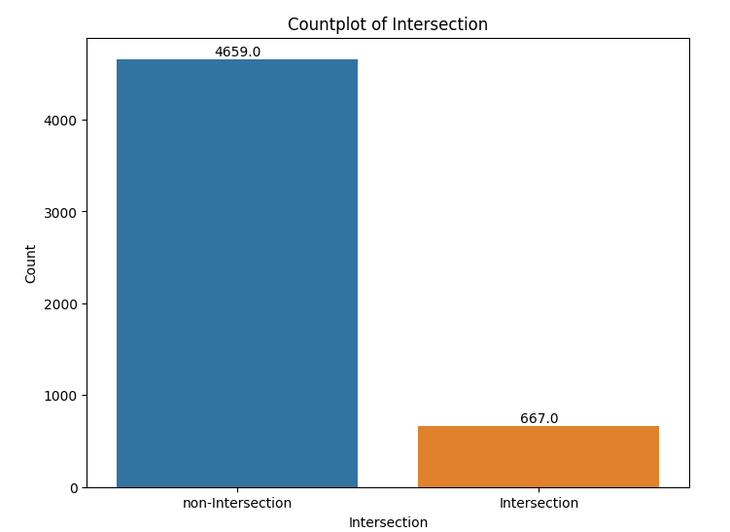
Furthermore, the categorical variables have been visualised through a count plot. It is evident that the number of roads is more dominant compared to other categories such as street, highway, drive, etc, the data depicts that most of these roads are non- intersection roads accounting for 4659 out of 5326 observations.

Bivariate analysis:
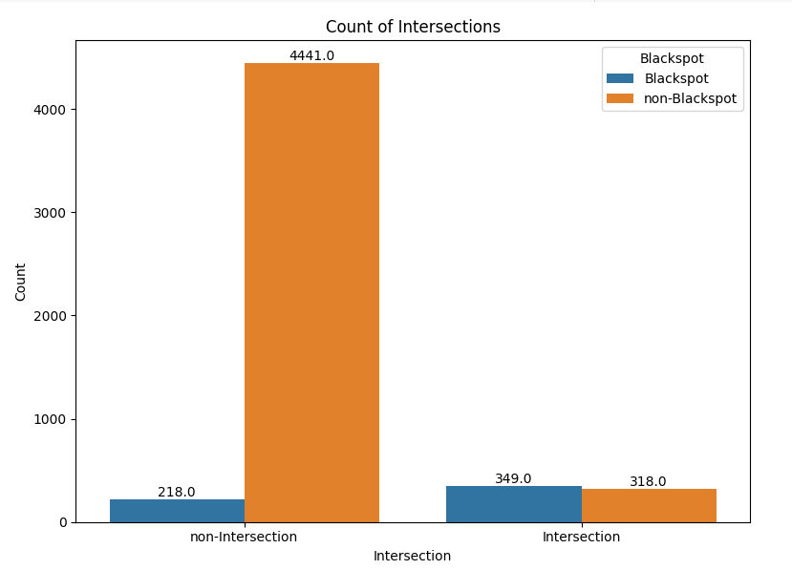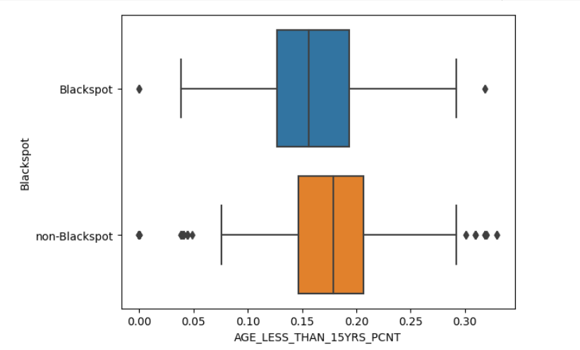

Analysis of relationship between 2 variables have been performed using visualisations. Count plot has given insights on the distributions of intersection and non-intersection and their association with blackspots. It is evident as per graph that non- Intersection Road generally exhibit lower likelihoods of accidents.
A series of boxplots were also generated analyse the relationship between numerical variables and Blackspot. The people in the age group of less than 15 years were equally distributed among the Blackspots and non- Blackspots with an IQR varying from 0.15 to 0.20. Non- blackspots having noticeably higher outliers.

Multivariate analysis:

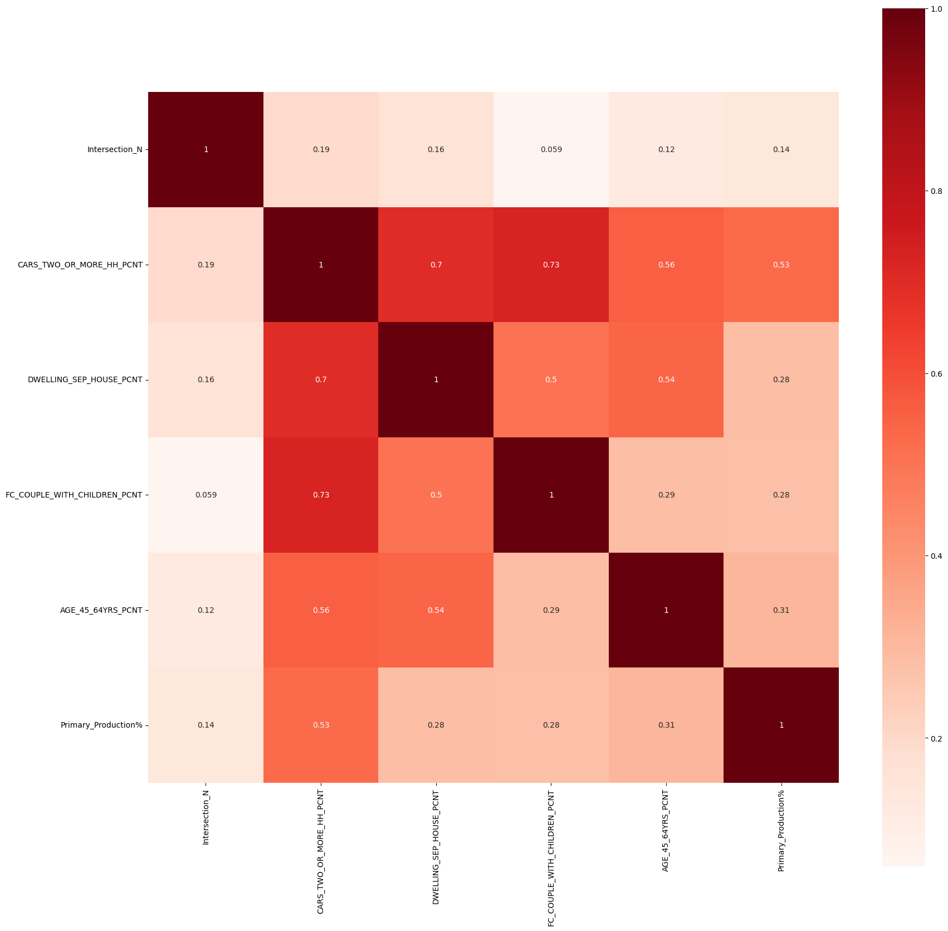
Heatmap

Filter method such as correlation filter technique has been implemented for selecting features that are highly correlated to Blackspots (V. Bolón-Canedo et al 2014). As per the heatmap features with the highest corelation with blackspot has been imbedded in logistic regression model. These features are intersection, CARS_TWO_OR_MORE_HH_PCNT, DWELLING_SEP_HOUSE_PCNT, Primary_Production%, AGE_45_64YRS_PCNT, FC_COUPLE_WITH_CHILDREN_PCNT.

The Machine learning model undertaken

Anticipating the occurrence of blackspots represents an aim to solve a classical problem. This consulting project is oriented towards forecasting a categorical result as opposed to a continuous one. To address this objective, VicCrashAnalytics has employed a logistic regression model to predict the emergence of blackspots. The model aligns seamlessly with the requisites of a binary classification task, tailored to foreseeing one of two potential outcomes. The model employed can help identify significant features contributing to blackspots.

The Model and the performance metrics

Feature selection and splitting the dataset

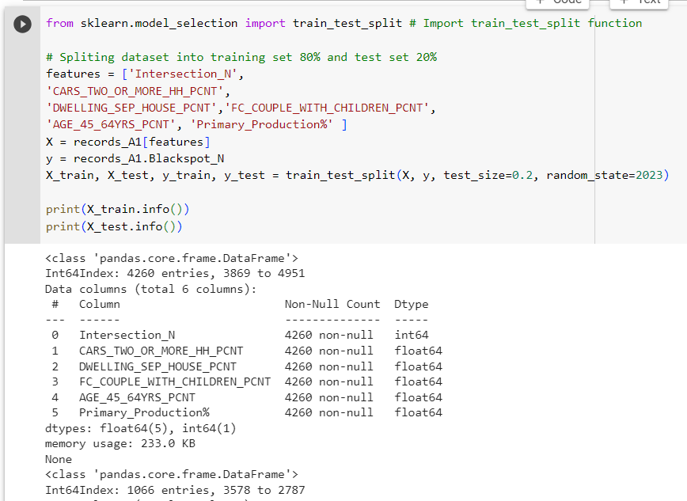

Dataset has been split into 80:20 ratio into training and testing sets for machine learning. Testing set has been created for evaluating the performance of the ML Model. Features which had high positive corelation with Blackspot have been selected and these features will be used to predict the target value ‘Y-variable’ i.e., Blackspot.
After crucial analysis using different variables in feature selection process, it was witnessed positively correlated values were more influential in determining the blackspots, leading to better accuracy and recall value for the Model. Furthermore, it’s crucial to split the dataset to ensure unbiased evaluation of the model.

Building the Logistic Regression Model:

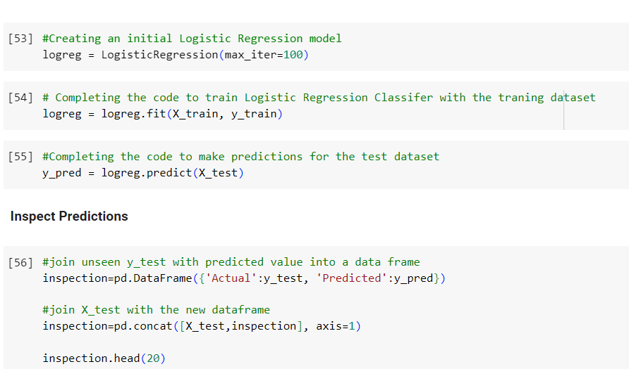

ML Model is further trained to learn the relationship between the features and the target labels. Trained model further predicts the target labels for the test data. After making predictions the actual target labels are used from the dataset to evaluate the performance of the model on unseen data.

Interpretation and insights

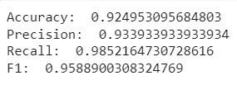

These metrics provide evaluation results of the machine learning model:
Accuracy of 0.92 indicates that 92% of the predictions made by the model are accurate. It highlights the overall effectiveness of the ML Model.
Precision measures the proportion of the correctly predicted positive instances out of all instances predicted as positives. A precision value of 0.93 indicates that 93% of the positive predicted are actually true positives.
Recall value: This evaluates the true positive rate. A recall of 0.98 means that the model is able to predict 98% of the actual positive instances.
F1 Score: The harmonic mean of precision and recall. It considers both false positives and negatives. F1 score of 98% means that the model has a good balance between precision and recall.

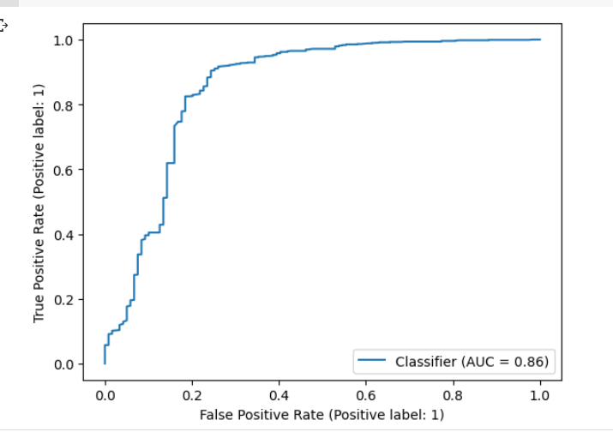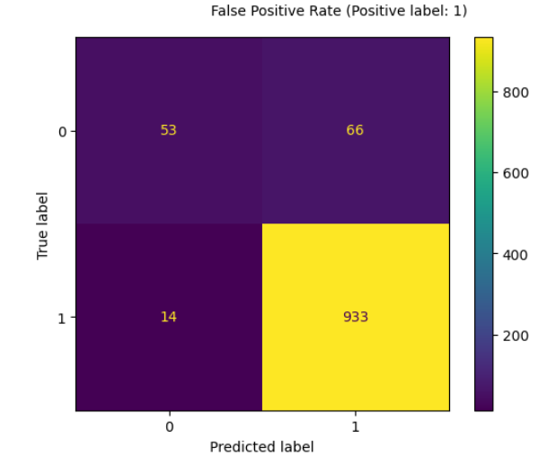
ROC Curve demonstrates an exceptional performance with an AUC of 0.86. AUC quantifies the overall performance of the model. A higher AUC indicates better discrimination between positive and negative classes. AUC of 0.86 is relatively high indicating a good discriminatory power.
Confusion matrix provides a more detailed breakdown of model’s predictions which is utlised to calcuate various metrics. The ML model employed was able to identify postive and negative values correctly.
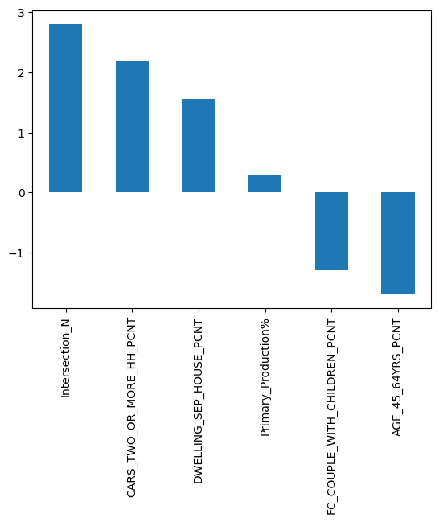
The impact of different features on the logistic regression model is displayed as above. Intersection and percentage of households with two or more cars have a major impact on the Blackspots in Australia, followed up with other features.

Pros and cons of the Logistic Regression Model
Pros:
- Offers an easy implementation, interpretation and dataset training
- Provides insights into significance and direction of the predictors
- Rapidly classifies unknown records
- Provides a good accuracy for simplified datasets

Cons:
- Logistic regression assumes a linear relationship between the dependent and the independent variables.
- It is limited to binary classification, not applicable with more than two classes
- Linear boundaries restrict the model to perform well with complex data.
Business solution and recommendations (Based on the model)

The analysis of the dataset provided by the Department of Transport (DOT) has yielded valuable insights to address the issue of blackspots. By conducting visualisations and building model, specific strategies have been identified that can be implemented to mitigate the risks associated with blackspots.

Intersection has shown a significant correlation with blackspots. To tackle this, prioritizing engineering improvements at intersection is highly essential. Traffic signal timings shall be optimized, better sign boards, street lights and convex mirrors shall be installed to enhance visibility and safety. Furthermore, Fisa R et al, 2022 suggested converting the intersections to roundabouts leads to a decrease in road accidents by 50%.

The variables such as more than two number of cars per household and couples with children provides insights into household compositions and car ownership patterns. By targeting households with multiple cars and children, campaigns shall be designed by DOT, promoting carpooling, use of public transport, obeying traffic rules and safety measures to be ensured while driving. Police presence and enforcements must be increased in areas prone to accidents and innovative technology such as intelligent traffic management system and road sensors shall be installed in Blackspot areas to enhance the safety.

The effectiveness of the model can be further enhanced by obtaining high quality data relevant to the transportation system in Australia and dropping the noisy data such as white collar or blue-collar population, people who speak only English, etc, Relevant official authorities shall provide with additional data regarding metrics like the traffic on that particular road.

The senior management of DOT, working together, government agencies, local communities, advocacy groups, and private sector entities with the motive to introduce legislative reforms would collectively contribute to a safer and more secure transportation network for all.

In a nut- shell, addressing the issue of blackspots requires a multi-faceted approach that combines various strategies and solutions. By prioritizing targeted solutions, we can create a safer road environment and prevent accidents effectively.

References

Ajitesh Kumar, March 26, 2023, Data Analytics, Vitaflux, Python – Replace Missing Values with Mean, Median & Mode.

Fisa, R., Musukuma, M., Sampa, M. et al. Effects of interventions for preventing road traffic crashes: an overview of systematic reviews. BMC Public Health 22, 513 (2022). https://doi.org/10.1186/s12889-021-12253-y

Great Learning Team, May 2023, Label Encoding Python- 2023
https://www.mygreatlearning.com/blog/label-encoding-in-python/

V. Bolón-Canedo, N. Sánchez-Maroño, A. Alonso-Betanzos, J.M. Benítez, F. Herrera, (2014), A review of microarray datasets and applied feature selection methods,
Information Sciences, 3.1 filters
https://doi.org/10.1016/j.ins.2014.05.042.

